Activity 3.2.3 Beam Analysis

Introduction
Once the design loads that will be imposed on a beam have been identified and quantified, the structural engineer must analyze the beam to determine the beam strength necessary to resist the applied loads. The maximum resisting forces due to the design loads, particularly shear and bending moment, must be calculated. A beam is then selected that can safely carry the required shear and bending moment. The maximum shear and bending moment can be represented using shear and moment diagrams.

Equipment
- Engineering notebook
- Calculator
- Pencil

Procedure
In your journal, complete the following for each of the beams. Note: All beams are simply supported and are 16 feet long. All uniform loads are w = 100 lb/ft. All concentrated loads are P = 500 lb.
- Cut out and paste the beam diagram into your journal.
- Sketch a free body diagram.
- Find the reaction forces/end shear using the equations of equilibrium.
- Sketch shear and moment diagrams.
- Calculate the maximum moment.
- Annotate the diagrams with the appropriate shear and moment magnitudes.

- Simple Beam – Concentrated Load at Center

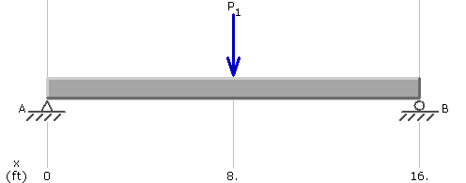

- Simple Beam – Uniformly Distributed Load

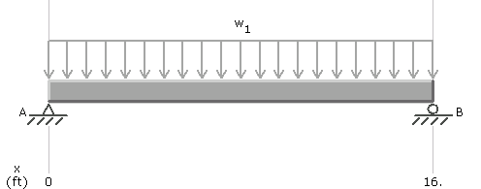

- Simple Beam – Uniformly Distributed Load and Concentrated Load at Center
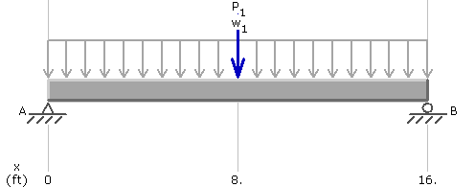

- Simple Beam – Two Equal Concentrated Loads -- Symmetrically Placed
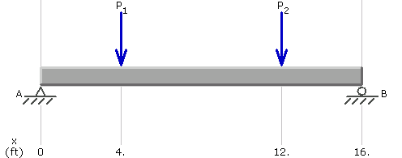

- Simple Beam – Two Equal Concentrated Loads – Symmetrically Placed and Uniformly Distributed Load
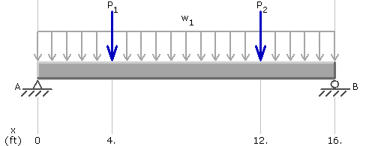

- Simple Beam – Concentrated Loads – Asymmetrically Placed
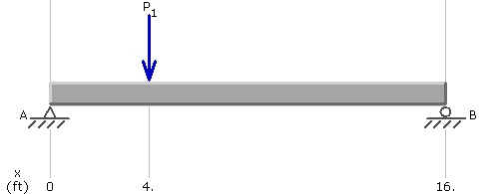

7. Simple Beam – Concentrated Loads and Uniform Load– Asymmetrically Placed

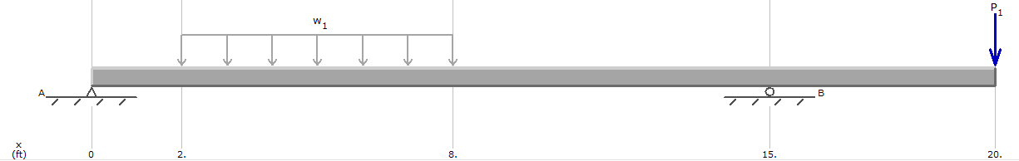

Conclusion
- What is common about the location of the maximum moment along the beam in each loading case?

- Note that loading case #3 is a combination of loading cases #1 and #2. What is the relationship between the maximum shear and maximum moment for loading cases #1, #2, and #3? For loading cases #2, #4, and #5?

- Can you identify similarities and differences in the shear and moment diagrams for these loading cases?
- What happens to the shear diagram at a concentrated load?
- What happens in the shear diagram when a uniform load is applied?
- What shape is the moment diagram when a single concentrated load is applied? Where is the maximum moment?
- What shape is the moment diagram when a uniform load is applied? Where does the maximum moment occur?

