Activity 6.3 Functional Analysis ALTERNATE

Introduction
Have you ever noticed how children are fascinated with how objects work? Many engineers have stated that they can trace back their interest in their chosen field to their childhood, when they would tear apart broken objects to figure out what caused them to move and function.

Reverse engineering is a process that relies on this childhood fascination with objects and how they work. The process involves the study of an object’s visual, functional, and structural qualities. Though it does not imply redesign, reverse engineering is often a tool that is used to aid in the redesign of an object so that its performance may be improved. Other reasons for performing reverse engineering include reducing an object’s negative environmental impacts, maximizing manufacturing techniques through the substitution of more appropriate materials, discovering how a competitor’s product works, and increasing a company’s profit margin.

You have performed a visual analysis of your selected product to identify the visual design principles and elements that give the object its visual appeal, or lack thereof. The next step in the reverse engineering process involves the study of the object’s function. This is done through careful observation of the object’s sequential operation before it is disassembled. By first observing the product, you can hypothesize how a product operates and then compare your predictions to your actual findings after the part is dissected.

Equipment
Example product observation
- Engineering notebook
- Pencil
- Automoblox vehicle or other consumer product

Procedure
In this activity you will analyze the function of your consumer product.

Before measurement and dissection, you must theorize how the product functions through non-destructive observation. Identify your product’s name and the company that produced it, and answer the following questions.

Product Name:
Company Name:

- What is the purpose or primary function of the object?

- Sketch an isometric pictorial of the product in your engineering notebook and label the individual components. If you are not sure what a particular component is called, then make a logical guess.

- Make an educated guess as to how this product operates. Use simple machines’ terminology to explain the object’s sequential operation.
- Identify the system inputs, intended product function, and outputs in the table below.
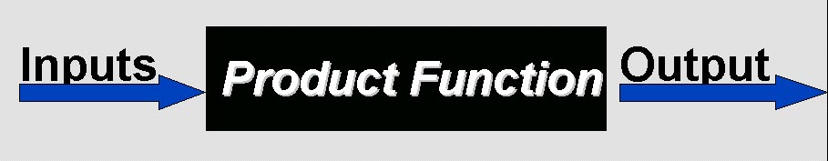
Inputs | Product Function | Output

- What mechanical components are visible?

- What is it about this device’s function that you cannot identify because the mechanical components are hidden from plain view?

Conclusion
- Why do engineers perform reverse engineering on products?

- What does a black box represent in the system input/output model?

