

|  |
| --- |
| **Activity 2.1 Isometric Sketching** |

Introduction

How do reading the face of a clock and sketching isometric pictorials relate to each other? Picture a cube in your mind. All of the surfaces of the cube form right angles with their adjacent faces. If you were to draw an isometric pictorial of the cube, you would see that the edges point toward 2 and 8 o’clock, 4 and 10 o’clock, and 6 and 12 o’clock. This idea helps when sketching isometric pictorials on writing surfaces that do not have isometric grids.

Isometrics are a common pictorial used both for concept sketches and to represent designs in technical drawings.

Equipment

* Pencil
* Isometric grid paper
* Orthographic grid paper, graph paper, or engineering notebook

Procedure

In this activity, you will develop your isometric sketching skills by first drawing isometric views of objects that are already given in an isometric orientation. You will apply your sketching skills in later exercises to sketch orthographic views of objects that are not given in isometric orientation and to represent your ideas and designs.

When referring to the orientation of an isometric view, the isometric view is labeled in the order of first face, second face, then third face. For example, the image on the left below shows a top, front, right side view isometric. The same object is pictured again on the right but is shown in a top, left side, front view orientation. We will almost exclusively use the top, front, right side view in this course. In fact, the orientation of the isometric will dictate how you label and show the orthographic projections (or side views) of the object in later activities.

**Activity 2.1 Isometric Sketching**

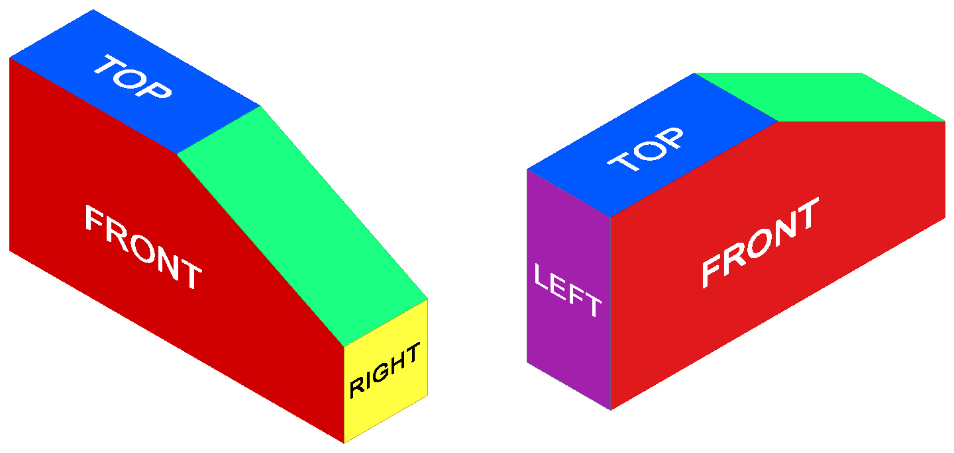

Top, Front, Right Side View Top, Left Side Front View

Reproduce the isometric view shown below to the left by completing the isometric pictorial of the object on the right. Use points and construction lines to lay out the isometric sketches. DO NOT ERASE YOUR POINTS AND CONSTRUCTION LINES.

|  |  |
| --- | --- |
| isometrics11e | isometrics11c  Top, Front, Right Side View |

Make isometric sketches of the three objects pictured below. Sketch the objects using the same orientation in which they are pictured. Use points and construction lines to lay out the isometric sketches. Then delineate the visible edges of each sketch with heavy object lines to make them stand out. DO NOT ERASE YOUR POINTS AND CONSTRUCTION LINES. Add tonal shading to the sketches when finished.

1.

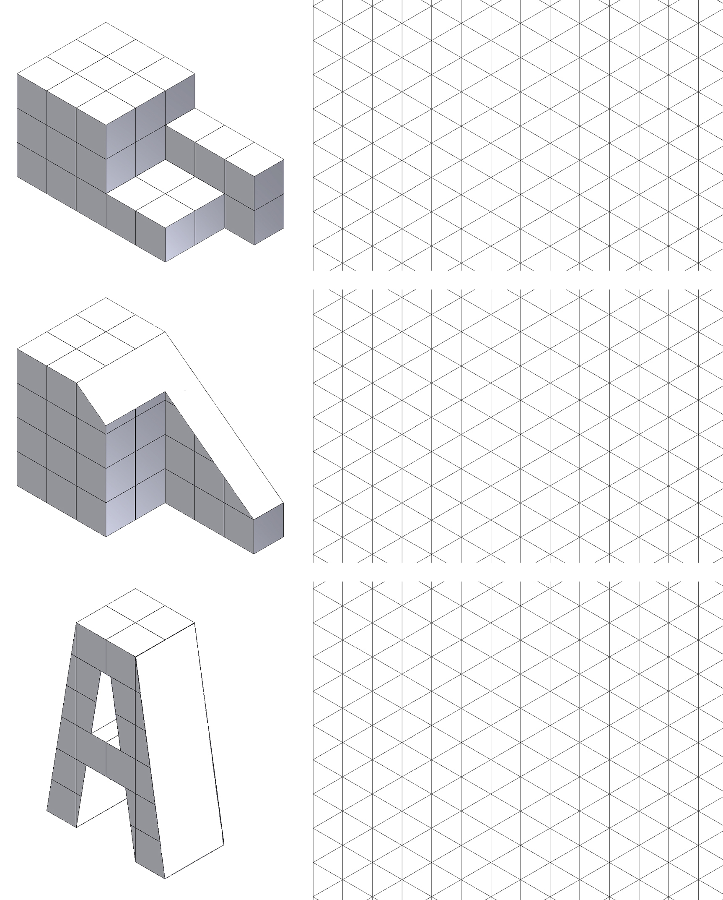

2.



3.



Study the isometric views below. Using the back side of grid paper, your engineering notebook, or graph paper (as indicated by your instructor) recreate the three isometric views for practice. Using the back side of the printed grid paper will allow more contrast between your object lines and the grid lines.

|  |  |  |
| --- | --- | --- |
| 4. | 5. | 6. |
|  |  |  |

7. Create an isometric sketch of one of the following objects. You do not need to measure the object, but try to represent the object at an appropriate scale to fill a quarter of a sheet of graph paper using correct proportions.

|  |  |
| --- | --- |
| * Highlighter, pen, or pencil * Toothbrush * Clothes pin * Flash drive * Coffee cup * Flashlight * Beverage can or bottle | * Monitor * Surge protector * Cell phone * Remote control device * Chair * Other instructor approved object |

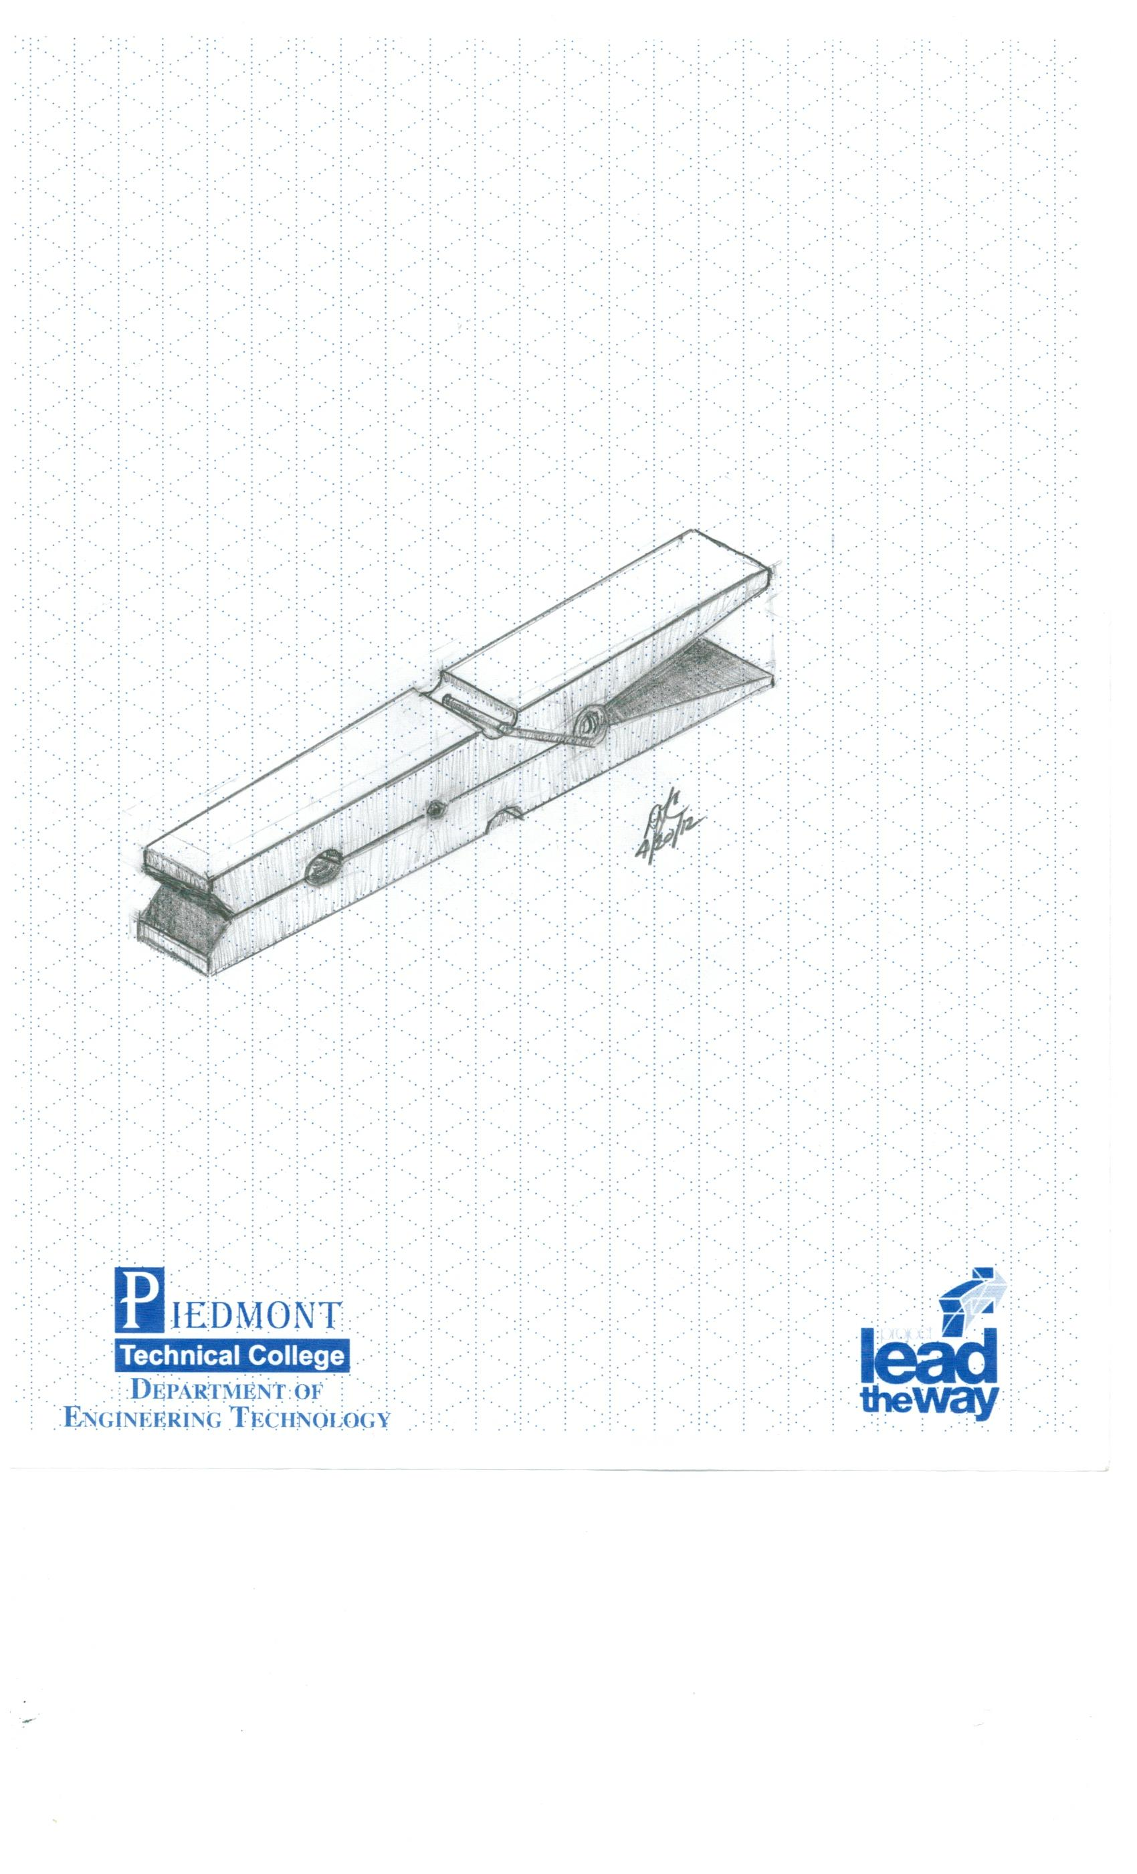

Conclusion

1. What are the advantages and disadvantages to using an isometric pictorial compared to using an oblique pictorial in technical drawings?
2. What is the difference between a two-dimensional sketch and an isometric sketch?
3. Why do designers use tonal shading?