Activity 3.2.6 Beam Design

Procedure
The PARTIAL SECOND FLOOR FRAMING PLAN for a new hotel is given below. The second floor will be used for conference space. Design the following floor framing members for the hotel structure.
- Interior beam
- Exterior beam
- Girder on Column Line 3
- Girder on Column Line 5

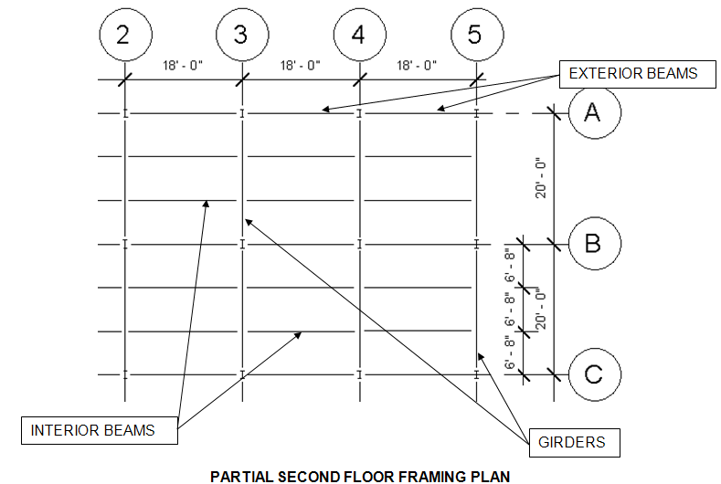

Criteria
The following data is to be used for design of the floor framing:
- Dead load = 50 psf
- Assume the weight of the floor beams and girders are included in the dead load.
- Floor live load = 100 psf (Hotels – Public Space per IBC 2009 Table 1607.1)
- F_{y} = 50,000 psi
- The floor will support a plaster ceiling.
- http://www.structural-drafting-net-expert.com/steel-beam.html

- Complete the following the interior beam using the Allowable Strength Design method. You must show all work and include proper units for full credit.
      - Calculate the loading
      - Create a beam free body diagram
      - Calculate end reactions
      - Draw Shear and Moment Diagrams
      - Calculate the maximum moment
      - Calculate the required nominal moment
      - Calculate required plastic section modulus
      - Choose an efficient steel wide flange to safely carry the load
      - Check shear capacity
      - Calculate deflection limits
      - Check deflection using beam formula; if necessary, revise member choice and recalculate deflection
      - Choose final design; prove that the revised choice is sufficient to carry bending moment and shear

Conclusions
- If the beam loading and beam span is different for every beam in a building, is it reasonable and practical to choose a different beam section for every installation? Why or why not?

- Aside from simply pushing the wrong keys on your calculator, what is the most likely reason for an error in calculating a required section modulus or a deflection?

- Which structural steel section would carry the largest bending moment, a W12 x 22 or a W14 x 22? Why? If subjected to the same magnitude of loading over the same span, which beam would display the largest deflection? Why?
Interior Beam

- Calculate the beam loading.

- Draw the beam free body diagram.

- Calculate the end reactions

- Draw Shear and Moment Diagrams

- Calculate maximum moment.

- Calculate the required nominal moment.

- Determine the required plastic section modulus and select an efficient wide flange.

- Check the shear strength.

- Calculate deflection limits.

- Calculate actual deflections.

- Select a final design.

