HOW TO START AN INVENTOR PART?
TUTORIAL 1
- Find Inventor Professional 2013 on your computer’s desktop-click once to open.

- After Inventor opens, click on ‘NEW’
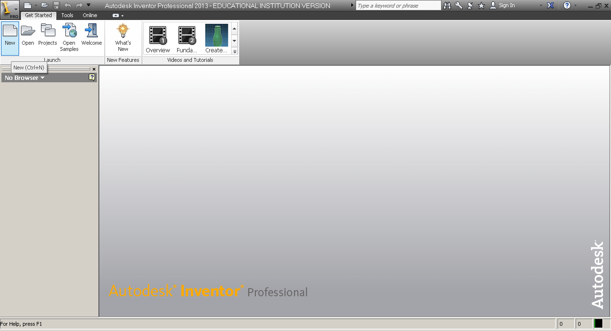

- For a new part-click on ‘Standard.ipt’

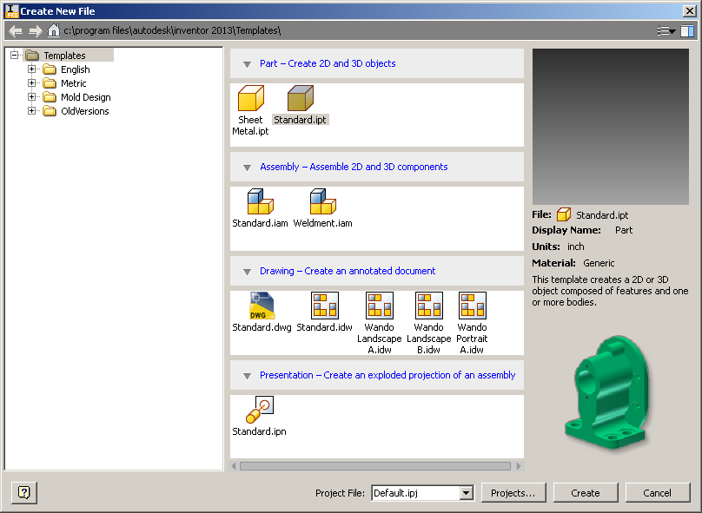
- To Create a white background; click on the ‘Tools’ tab on the ribbon; then click ‘Application Options’

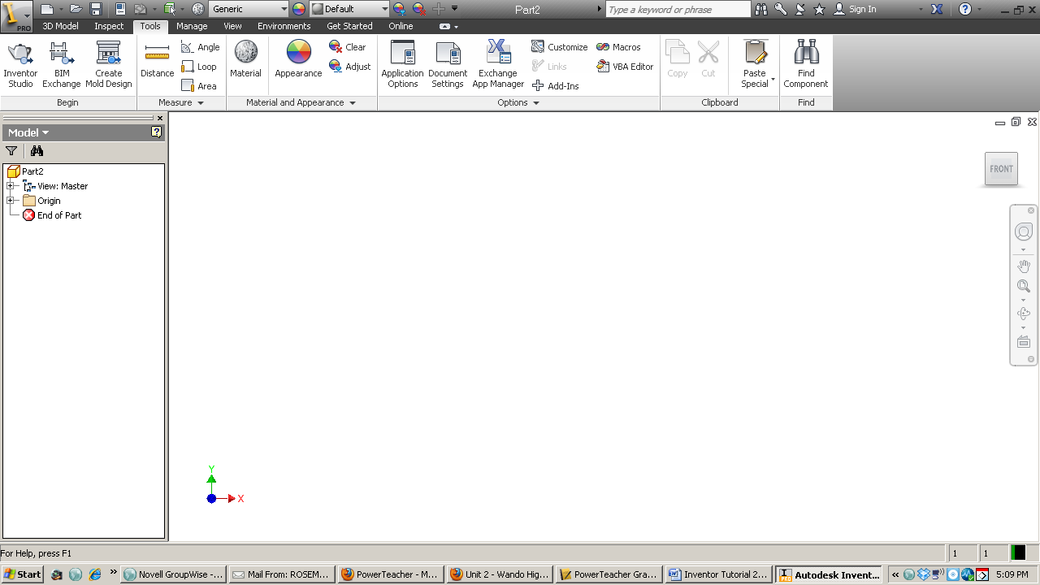

- After you click on Application Options, it opens a dialogue box
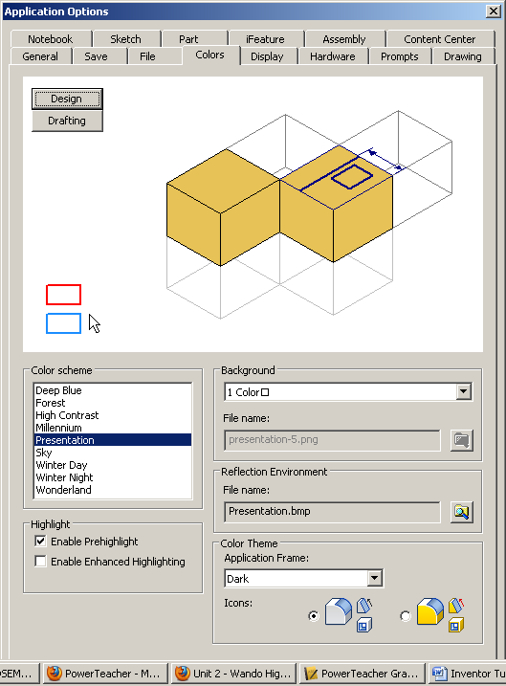
  - To change the background of Inventor to white: Click on the ‘colors’ tab. Choose the ‘Presentation’ Color Scheme, and the ‘1 Color’ Background.
  - To make grid lines show up: Click on the ‘Sketch’ tab and under Display check ‘Grid lines’.
